

Assignment 1  
Keyword Research and Page Optimization

Learning Outcomes

1. Basic understanding of search engine optimization
2. Familiarity with industry standard SEO tools
3. Basic keyword analysis
4. Page optimization and technical SEO techniques

Submission Instructions

To get credit, students will download, complete and submit this completed document before the posted due date posted in Canvas.

Keyword Research

Keyword research is an important first step in any SEO strategy. In order to get people to your site, you must first know which words they already using to find you.  Often times, the terms people are actually using may not be exactly what you expect.  For example, let's imagine we own a small craft brewery.  This brewery makes many different styles of beer but their light beers seem to be best sellers.  The Brewery has a website that is optimized for the terms “light beer” or “lite beer”.  We think these are good terms because they encompass a variety of products and are in line with popularity.  But when we dig a little deeper, we realize that using these terms may be hurting our search results instead of helping!

When we search for “light beer” or “lite beer” we are presented with links to the websites of Miller, Coors and Budweiser.  As much as I would like my small brewery to compete with these mega-brewers, it is just not realistic.  In fact, my website does not show up on the first or second page using when searching for these terms.  How can this be?  I thought my site was “optimized”?

Well, the truth of the matter is that my site is optimized, just not for the right terms.  More specific terms like “blonde ale” or “new york pale ale” or “best pale ale in northeast” would be much better.  First, when I test these terms the results seem to be much more in line with my actual business competitors.  Also, someone who is searching for a very specific type of beer that I offer is typically a better qualified lead than someone simply looking for a generic light beer.

Now that we know the truth about how people  find us, we need to rethink the content, markup and possibly the structure of our website to **optimize** it for these new search terms.

Product of Service

For the purposes of this assignment, you will be analyzing the the product or service you have chosen for the semester.   Pay close attention to the terms they currently  use to describe their product or service.  Are there specific terms that seem to be used repeatedly?  Can you start to guess what users might type into a search engine (Google)  to find this product or service?

Brainstorming

Believe it or not, most keyword research starts with a series of guesses.  Marketers and SEO professionals simply take educated guesses on what terms customers might use to find their product or service.  This may seem a bit unscientific — and it is — but this stage of the research process is just about creating a starting point.  We will refine this list later.

Task #1

Using the space below, create a list of words or phrases that a Google user might use to find your product or service.  List at least **20 terms or phrases** to start.  Don’t limit yourself at this point, put  down any terms or phrases you think might be relevant.   You may include [branded and non-branded terms](https://searchenginewatch.com/sew/how-to/2405547/brand-vs-non-brand-measurement-is-key).

1. College taxi near me
2. Ride share service
3. Car service
4. best car service
5. Ridesharing app
6. Uber app
7. Taxi driver app
8. Student driving job
9. Airport ride
10. Free uber ride
11. Uber discount code
12. Taxi app
13. Car transportation mobile
14. Driver bonus
15. Smartphone ride app
16. Uber driver
17. No reservation car service
18. Black car
19. Uber fare estimate
20. San Francisco rider app
21. Car service background
22. Black car airport service

Now that we have our basic keyword list, let's add some variations.   We do this by adding “stems” to our list of brainstormed terms.  Stems are words like “How do I _______” or “Where can I ________” that are added to the beginning or ending of the original keyword or phrase.  These stems can take a very generic term and make it much more specific.  These stems added to the keyword list above create what is known as “long tail” keywords.  [Google suggest feature](https://www.searchenginejournal.com/beginners-guide-google-suggest-marketers-seo/73269/) can help with this process.

Task #2

See if you **can come up with at least fifteen long tail keywords** in the space below that will work to attract the right customers to your company's website.

1. Taxi to downtown Syracuse
2. How much does it cost to get from SU to the Syracuse Airport
3. How much can I make driving for uber
4. How do I become an uber driver
5. Where can I get an Uber discount code
6. How to get 1st ride free uber
7. Where can I use uber
8. How to use uber
9. What is the most affordable rider app
10. Where can I get a black car
11. Uber fare estimate
12. Which driver app background check drivers
13. Find an Uber Promo code
14. How to ride with uber
15. How do I know my uber promo code

Analysis

Now we are going to analyze our keyword list to see how close we actually are to keywords that people are actually using for search.  There are many tools out there that can help us research and plan keywords for any particular web page.  [Google’s AdWords Keyword Planner](https://adwords.google.com/KeywordPlanner) and the [free version of WordTracker](https://freekeywords.wordtracker.com/sign_in/) are popular choices.

Suggested Keywords

To get started access the [Google AdWords Keyword Planner Tool](https://adwords.google.com/KeywordPlanner).  In order to access the tool, you will need a Gmail account, and you will need to sign up for Google AdWords.  AdWords is Google’s online advertising product for placing pay-per-click ads and display ads.  We will use this tool again later in the semester.  Once you have access to the Keyword Planning Tool, click the “Search for new keyword and ad group ideas” option.

**NOTE: You do not have to pay for this service.**  If you are having trouble gaining access to the keyword planner tool contact myself or our TA for the course.

Enter information about our product.  In the top box labeled “Your product or service” you can enter one or multiple terms that describe your product or service.  Separate the terms with commas. Below is an example of the completed form.  You can be as generic or as specific as you want however you may notice that the keyword planner tool results will vary based on the information you enter on this form.

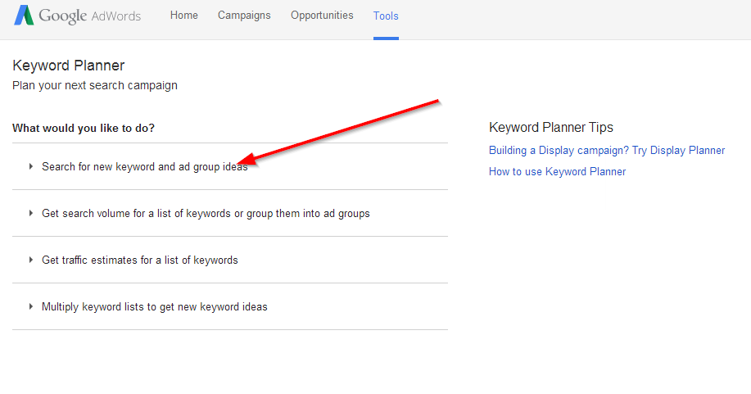

After you have completed the form, click the “get ideas” button at the bottom of the form.  You should be presented with a results screen that looks something like the one below.  By default, the results page presents you with the “Ad group ideas” tab selected.  This Keyword Planning tool is primarily designed to support Google’s AdWords product, that is why this result is the default view.  We will learn more about this later in the semester.  In order to see a list of possible search terms or “keywords”, be sure to click the “keyword ideas” tab at the top of the results screen.

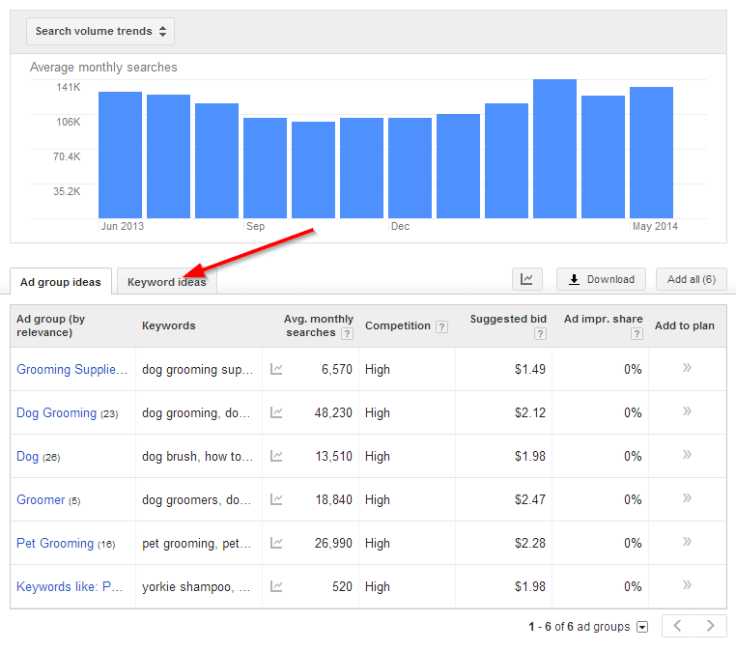

Take a look at the suggestion the Keyword Planner tool has provided.  Are they in line with your original brainstorm list?  Are there any surprises?  Go back and change some of the text you entered on the form.  See how it affects the suggested keyword list.

Task #3

Take a screenshot of **the** suggested keyword list and paste it in the space below.

After looking at the suggested keywords what have you learned?  How will you make adjustments?

After looking at the keyword Ideas I’ve learned that the majority of searches are branded and relate directly to uber. Moving forward I will take this into consideration and edit my list accordingly.

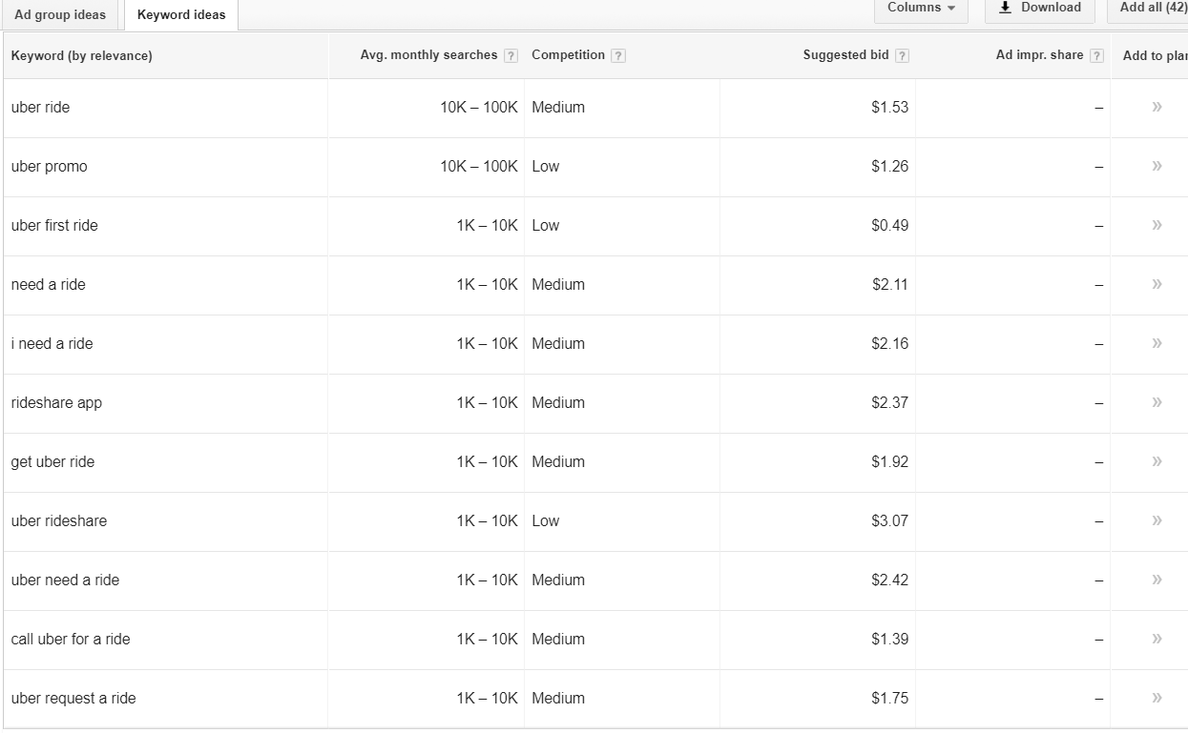

Relevance

Knowing what terms users are searching is one thing, but making sure those terms accurately describe your product or service is another.  Take a look at the suggested keywords from the previous steps.  Do they accurately describe your product or service?  Think to yourself, “When the user searches this query, what are they looking for? What do they want? If they find my site, will it meet their needs?”  If your results are like mine, most suggested terms should be fairly relevant, however there are usually a few terms that are way off base.  That is ok, just take note of the terms you think are bad.  We will use this to help refine our list later.

Search Volume

Our next step is to analyze search volume and competition for the suggested terms.  You may have noticed a column that reads “Avg. Monthly Searches” on your keyword suggestion list.  This metric is exactly what you think it is, the average number of times per month Google users enter this term into the search engine and request a result.

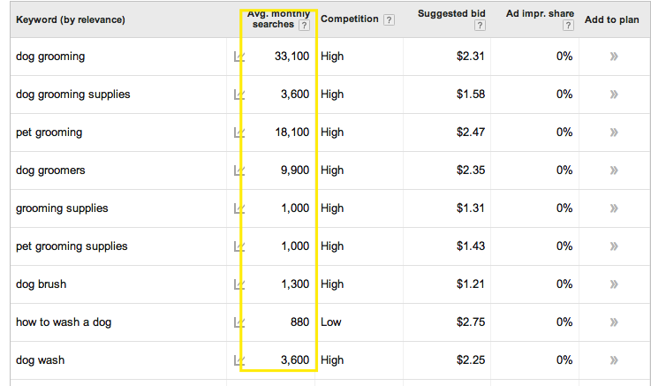  
  
We are going to use this metric to refine our keyword list even further, but here is where things get a little tricky.  We don’t necessary want to choose all the terms that have the highest average monthly searches.  We may want to include more specific long tail terms that have a highly likelihood of getting people to your site.  Take a look at the example below.   
  
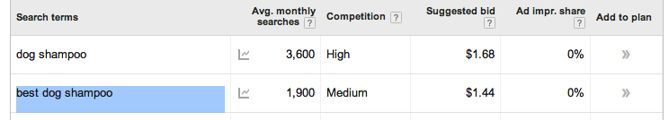  
The term “dog shampoo” has 3600 monthly searches but high competition.  The search phrase “best dog shampoo” has 1900 average monthly searches but lower competition.

Task #4

In the space below, tell me **which term in the above example** do you think would be a more effective in terms of getting users to your site and why?

I think the 1900 “best dog shampoo” search will get more users to the site because it has a lower competition space and therefor will be easier to compete with and the likelihood of your “optimized” page ranking higher on a SERP is better.

Task # 5

Do you best to narrow down your terms based on what we have learned so far.  Get rid of terms that you think are not very relevant to your product or service and add good suggested terms from your keyword research.  You may also want to remove terms that do not get enough search volume.

At this point you should try to get your list down to about **ten to fifteen high quality terms**. **Paste those terms in the space below.**  Remember, there is no right answer here, SEO is an iterative process of elimination.

1. Uber ride
2. Ride with uber
3. I need a ride
4. Mobile car service app
5. Black car service app
6. 1st ride free
7. Uber discount code
8. Request a ride
9. Uber promo
10. What is the most affordable rider app
11. How to call uber
12. No reservation black car

Now it is time to get tough and take a good look at our competition.  This phase of the keyword research process is about making sure we are competing in the right space, using the right terms.  We want to make sure that the search results for any targeted terms are right for our product.

To start our competition analysis, select one of your targeted terms from your refined list.  In the example below I chose to use “best dog shampoo” as my selected term.  Type the term or phrase you selected into a normal Google search box and take a look at the results.  Are these your competitors?  If you think they are, take another look…are they really?  
  
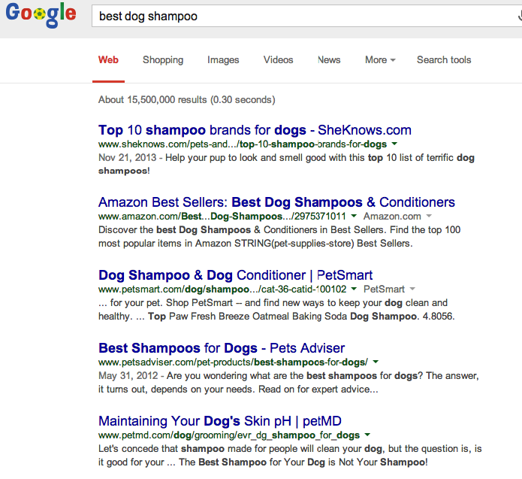

In the example above, you can see that this term yields results that are not exactly direct competitors.  The results for this term are mostly how-to blog articles and large online retailer sites.  For this particular website my direct competitors would be actual shampoo manufacturers, not retailers and bloggers.

Let's try another term.  This time I typed “all natural dog shampoo” into Google.  If you look at the results for this term you can see that most of the results are actual shampoo manufacturers, not retailers.  These results also seem to similar to my product in terms of the size of the company as well.  This is good!  We are getting closer!  
  
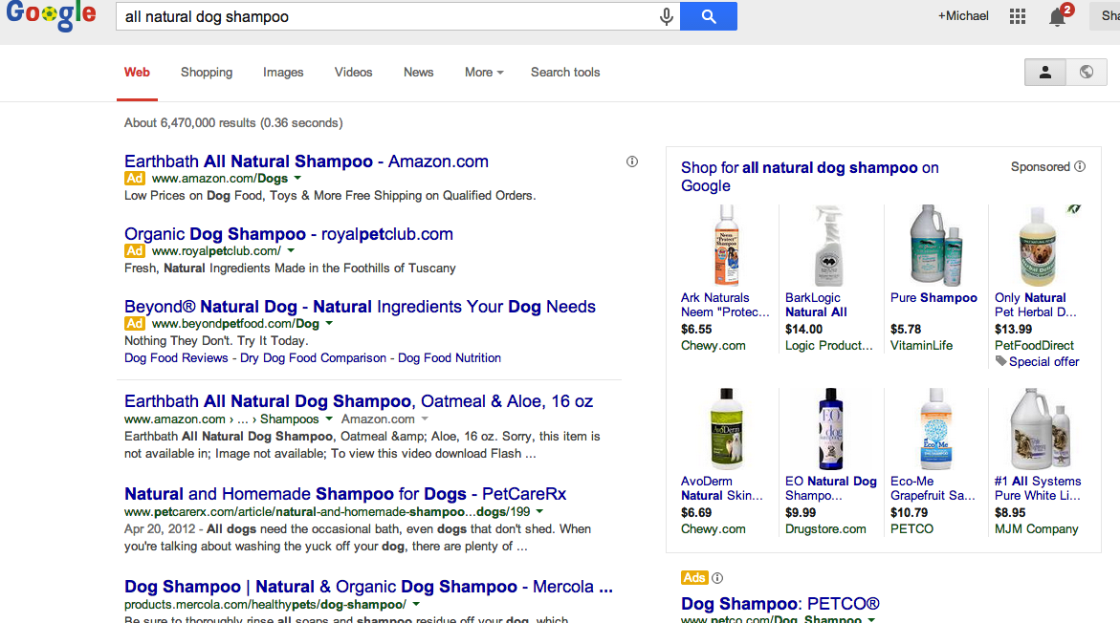

Task #6

Run this same competitive analysis test on all ten of your targeted keywords.  See if you can narrow down the list even more.  Try to **narrow your list  down to the five most relevant**, highly searched, least competitive and most accurately competitive terms.  **Paste your terms in the space below**.

1. Uber ride
2. I need a ride
3. 1st ride free
4. Uber discount code
5. Uber ride

Page Optimization

Selecting the best possible terms for your product or service is just half the battle.  Once we have terms we would like to target, we now need to add those terms to our web content.  After all, if we want people to find our product page by searching “all natural dog shampoo” we better make sure that the words “all natural dog shampoo” actually exists on our webpage!

There are many, many factors that affect how “optimized” a page is for any particular term.  [This article written by SEO Moz](http://moz.com/beginners-guide-to-seo/basics-of-search-engine-friendly-design-and-development) does a good job explaining the basics of what search engines like, and what they don’t like.  Read through it to get a better understanding of what it takes to optimize a page.

Task #8

After you have read through this article take some time to explain what changes you would make to your product or service’s website.  These changes should be based on the keyword research you did earlier and the information found in the Moz article and what we have learned in class.  In a list of bullet points **tell me what you would changes you will make to your website and why**.  I expect you to cite **at least 6 page optimizations** in your answer.

1. I will be changing my “product” from an imaginary more specialized product to just “Uber – Ride”
2. On-Page Optimization: Title Tag - I will change my header to be Ride with Uber
3. I will be inserting images with descriptive tags
4. On-Page Optimization: Static URL - I will change my URL to be Ride with Uber | Uber
5. On-Page Optimization: Share - I will add social sharing buttons
6. On-Page Optimization: Meta Description - I will add a meta description
7. I will use the word “Ride with Uber” repetitively throughout the body of the page

Task #9

Now that you have plan, go in and make the changes you have outlined above to your website.  Please be sure to p**lace a comment in your HTML code where you have made a change.**  In class we will work to host your websites online.  Commit your changes using Git and push to your GitHub repository.    Once hosted and tested in GitHub, **submit the URL to your GitHub Page below**.

Link Building

Task #10

Another important tactic in a solid SEO strategy is link building.  Gaining links from reputable sources with high domain and page authorities is a difficult task.  Take a minute to think through where might focus your link building efforts for this particular product.  What sites, blogs or directories might you reach out to?  What link building tactics would you use and why?  Please write a few paragraphs in the space below explaining your strategy.

I would begin by reaching out to social media influencers who have a large following especially on Instagram. By posting a promotion for new users they will give their followers access to a promo code for a free ride and in return the poster will also receive a free ride after the new customer redeems theirs.